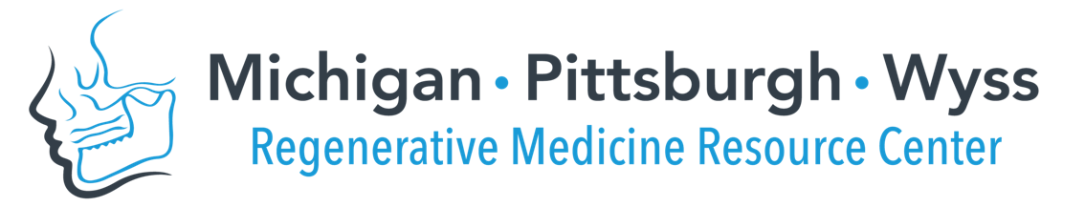

Interdisciplinary Translational Project Program, Cycle 6
Pre-Proposal Application
Due June 1, 2021 (Tu) by 5pm (Eastern) @ http://bit.ly/MPWRM_ITPCycle6pre

Please use the template below and use no smaller than Arial 10pt. font. Pre-Proposal (Applicant and Project information + Questions 1-4) should not exceed 2 pages (exclusive of References). Text in gray may be deleted.

Applicant information
Applicant name (Last, First):
Institution/ Company:
Project information
Project Title:
- Unmet clinical need/ market opportunity
Describe the unmet clinical need in the dental, oral, craniofacial (DOC) space and market opportunity to be addressed by the proposed technology/ solution.
- Which specific patient population/ market segment is addressed?
- What is the current standard of care? What other approaches exist to solve this clinical need?
- What are the needs from the various stakeholder’s perspective (end user/ patient, clinician, payer, etc)?s
- What is the value proposition?

- Proposed technology/ solution

Provide a clear and concise description and the innovation surrounding the approach.
- For which patient population would the proposed solution be applicable?
- What are the specific measurable benefits of the proposed approach vs. the current (gold) standards?
- How would the proposed technology/ solution be incorporated into or replace the standard of care?
- What is the anticipated regulatory pathway for the proposed solution/ technology?

- Project Background

Describe research/ development completed to date to establish technology readiness towards translation of the solution to the clinic.
- What is the current stage of translational development? (large animal, FDA submission?) Please include a summary of proof-of-concept studies completed in a DOC-relevant model.
- What is the current IP status of this technology (disclosure to your Technology Transfer Office, patent/ licensing status)?

- Project Plans and Milestones
Describe the plans and goals to be accomplished during the funding period, including specific milestones. Discuss how the successful achievement of these goals will motivate the next stage of development (e.g. pre-submission meeting with FDA, advance to manufacturing for commercialization).
- What key experiments are proposed to further demonstrate commercialization/ clinical translation potential of your technology? How does the successful completion of these plans bring the proposed technology/ solution closer to clinical/ commercial translation?
- What is the overall commercialization/ translational plan for this technology?

References

