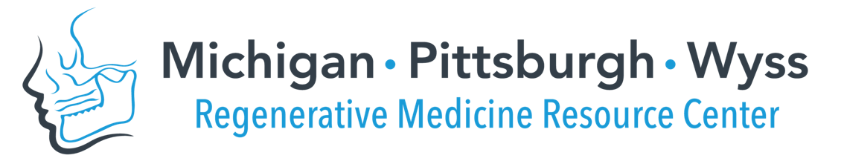

Interdisciplinary Translational Project Program, Cycle 8
Pre-Proposal Application
Due November 1, 2022 (Tu) by 5pm (Eastern) @ http://bit.ly/MPWRM_ITPCycle8pre

Please use the template below and use no smaller than Arial 10pt. font. Pre-Proposal (Applicant and Project information + Questions 1-4) should not exceed 2 pages (exclusive of References). Please delete instructional text in gray before submission.

Applicant information
Applicant name (Last, First):
Institution/ Company:
Project information
Project Title:
- Unmet clinical need/ market opportunity
Describe the unmet clinical need in the dental, oral, craniofacial (DOC) space and the market opportunity to be addressed by the proposed product/ solution. Information from any customer discovery to date should be included.
- For the pursued indication, what is the current standard of care/ other existing approaches to solve this clinical need?
- Who is the customer? What are the needs of the various stakeholders? (patient, clinician, payer, etc.)
- What is the value proposition?
- Proposed product/ solution

Provide a clear and concise description of the proposed product/ solution.
- What is the proposed product/ solution? What does it do?
- What are the specific/ measurable benefits of the proposed product/ solution over the current (gold) standard?
- How would the proposed product/ solution be incorporated into the current clinical workflow?
- What is the anticipated regulatory pathway for the proposed product/ solution?

- Project Background

Describe research and development completed to establish technology readiness towards translation of the product/ solution to the clinic.
- What is the current stage of translational development? (large animal, FDA submission?) Please include a summary of proof-of-concept studies completed in a DOC-relevant model.
- What is the current IP status (patent- filing date/ status, licensing status)?

3a. Your perceived Technology Readiness Level (TRL):

Please review https://ncai.nhlbi.nih.gov/ncai/resources/techreadylevels and the provided table of TRL (see Excel link provided in the above website) and provide your assessment of the project TRL
- Project Plans and Milestones
Describe the plans and goals to be accomplished during the funding period, including specific milestones. Discuss how the successful achievement of these goals will motivate the next stage of development (e.g. pre-submission meeting with FDA, advanced manufacturing for commercialization, etc.).
- What key activities are proposed to further demonstrate commercialization/ clinical translation potential of your product/ solution? How does the successful completion of these plans bring the proposed product/ solution closer to clinical/ commercial translation?
- What is the overall commercialization/ translational plan for this product/ solution?

References

